Policy on Practicability Analysis for Runoff Reduction

Introduction
Runoff reduction practices are stormwater Best Management Practices (BMPs) used to disconnect impervious and disturbed pervious surfaces from the storm drainage system. The purpose is to reduce post-construction stormwater runoff rates, volumes, and pollutant loads. Runoff reduction is more than simple infiltration. The Runoff Reduction Volume (RR_{V}) is the retention volume calculated to infiltrate, evapotranspirate, harvest and use, or otherwise remove runoff from a post-developed condition to more closely mimic the natural hydrologic conditions.
Certain conditions, such as soils with very low infiltration rates, high groundwater, or shallow bedrock, may lead a local jurisdiction to waive or reduce the runoff reduction requirement for proposed site development on a case-by-case basis. If any of the stormwater runoff volume generated by the first 1.0” of rainfall cannot be reduced or retained on the site, due to site characteristics or constraints, the remaining volume shall be increased by a multiplier of 1.2 and shall be intercepted and treated in one or more best management practices that provide at least an 80 percent reduction in total suspended solids.
The Policy on Practicability Analysis for Runoff Reduction (practicability policy) was developed to provide guidance about the site conditions and supporting documentation that could justify a “Determination of Infeasibility” for the runoff reduction requirement. This practicability policy does not address infeasibility for linear transportation projects being constructed by the local jurisdiction, other local governments, or authorities.
The practicability policy is based on the following principles:
- It is designed to help administrators implement a process for granting a Determination of Infeasibility that supports efficient review of land development applications.
- It applies to new development and redevelopment projects for public and private post-construction stormwater BMPs. It is referenced in the Model Ordinance for Post-Construction Stormwater Management for New Development and Redevelopment (Model Ordinance) developed by the Metropolitan North Georgia Water Planning District (Metro Water District).
- It aligns with requirements for runoff reduction in the Georgia Environmental Protection Division’s (EPD’s) permit to discharge from the municipal separate storm sewer system (MS4) permit. The MS4 permit states that the stormwater management system shall be designed to retain the first 1.0 inch of rainfall on the site to the maximum extent practicable. Most Georgia Stormwater Management Manual (GSMM) BMPs include a runoff reduction component.
- It is focused on the typical site conditions and regulatory environment in the Metro Water District and may not be applicable for all of Georgia.
- It requires a pre-submittal meeting when pursuing a Determination of Infeasibility to ensure all attempts to provide 100% RRv on site have been exhausted.
The local jurisdiction is responsible for the review of land development applications and determination that it is infeasible to apply the runoff reduction requirement on part or all of a proposed site development. Local jurisdictions may choose to make substantive changes or otherwise customize this practicability policy. These further changes and customizations are allowable so long as their substance meets the requirements of a local jurisdiction’s MS4 permit. EPD is responsible for evaluating MS4 permit and District Plan compliance, which includes verifying whether changes and customizations are “at least as effective.” EPD has reviewed this document and their comments have been incorporated.

Conditions that may warrant a Determination of Infeasibility
The GSMM provides broad guidance about conditions that may lead a local jurisdiction to waive or reduce the runoff reduction requirement. The following conditions may warrant a Determination of Infeasibility.
- Soil Infiltration Rate: The soil infiltration rate is less than 0.5 inch per hour as measured over a meaningful portion of the site. Consideration should be given to infiltration rates throughout the soil profile.
- Water Table: The seasonal high-water table is less than two feet from the bottom of an infiltration practice.
- Shallow Bedrock: Material that cannot be excavated except by drilling or blasting AND is less than two feet from the bottom of an infiltration practice.
- Extreme Topography: In the proposed final condition, as shown on the Stormwater Concept Plan with the proposed post-development condition, anything steeper than 3:1 slope for more than 50% of the site.
- Karst Topography: Any of the existing condition is karst.
- Hotspots/ Contamination: Reasonable suspicion that previous uses of the site have resulted in soil contamination.
- Historic Resources: Buildings, structures, or historic sites included in the Georgia Historic Preservation Division’s Historic Resources Survey or listed in the National Register of Historic Places or that has been recommended as a historic resource by a Preservation Professional.
- Site Constraints: Sites where the density or nature of the proposed redevelopment would create irreconcilable conflicts for compliance between the on-site runoff reduction requirement and other requirements such as zoning, floodplains, stream buffers, or septic fields.
- Economic Hardship: The cost of retaining the first 1.0 inch of rainfall onsite using runoff reduction practices is a minimum of three times greater than the cost of providing water quality practices. This condition must be present with another site condition for a Determination of Infeasibility. Additionally, a Determination of Infeasibility for economic hardship may only be allowed for up to 50% runoff reduction volume.

Supplemental Materials
The District has prepared supplemental materials to support the implementation of this practicability policy. Appendix A is meant for internal use and provides an overview of the steps a local jurisdiction could take to implement the practicability policy and issue a Determination of Infeasibility. Appendix B has a template the local jurisdiction could use as a runoff reduction infeasibility form.

Appendix A:
Overview of Processing a Determination of Infeasibility
Overview of Processing a Determination of Infeasibility
Obtaining a Determination of Infeasibility
Determination of Infeasibility is not an all or nothing proposition. Designers must demonstrate that they have explored all avenues to meet the runoff reduction standard. If this is determined to be infeasible, they must attempt to provide the maximum percentage of RRv on site as feasible. Only after all attempts to provide any RRv on site are exhausted will the local jurisdiction consider a Determination of Infeasibility. The following process is recommended to:
- identify conditions early,
- provide flexibility,
- support efficient land development application review, and
- protect water quality to the maximum extent practicable.
Does the Site Qualify for a Determination of Infeasibility?
Answering “NO” to any of the following questions may indicate that the site qualifies for a Determination of Infeasibility:
- Can GSMM runoff reduction BMPs fully meet the runoff reduction volume?
- Does the site analysis show the conditions are supportive for managing the calculated runoff reduction volume needed for the site?
- Can better site design practices (see GSMM, Volume 2, Section 2.3) be used to avoid challenging site conditions or constraints?
- Can BMPs, such as green roofs and rainwater harvesting techniques, be used in ways that do not require infiltration into subsurface soils, but rather rely on evapotranspiration and reuse?
- Can the installation of multiple runoff reduction BMPs, such as installing runoff reduction BMPs at higher elevations or in multiple sub watersheds, manage the calculated runoff reduction volume needed for the site?
Prior to Construction
- The design professional identifies conditions that limit using runoff reduction methods to retain 100% of the first 1.0 inch of rainfall onsite and initiates a pre-submittal meeting with the plan reviewer prior to submittal of the land development permit application. During the meeting, the following information will be reviewed:
  - Runoff Reduction Infeasibility Form to initiate the request and provide basic project information, confirmation that supporting documentation was submitted, and documentation of pre-submittal meeting outcomes.
  - Stormwater Concept Plan that has been developed based on site analysis, and natural resources inventory (including impracticability) in accordance with Section 2.4.2.5 of the GSMM.
- The plan reviewer will evaluate the pre-submittal information on a case-by-case basis; coordinate with the design professional to understand site-specific issues; and (if possible) explore potential design strategies to achieve 100% RRv in compliance with the standards and specifications of the Post-Construction Stormwater Management Ordinance and GSMM.
- Based on the pre-submittal information and meeting, the plan reviewer will provide one of the following determinations to the design professional:
  - Approval – preliminary Determination of Infeasibility issued
  - Approval with conditions – preliminary Determination of Infeasibility issued with conditions to incorporate plan reviewer comments into the Stormwater Concept Plan
  - Denial - revise the Stormwater Concept Plan to obtain 100% RRv

- Design professional may either:
  - Submit the land development application with the Stormwater Management Plan and preliminary Determination of Infeasibility (as applicable).
  - Appeal the “denial” or “conditions” following the appeals process outlined in the local jurisdiction’s regulations.
During Construction
- During the development process, the owner encounters a site condition that would prevent building stormwater BMPs as specified in the Stormwater Management Plan. The design professional will complete a Runoff Reduction Infeasibility Form and initiate a meeting with the local jurisdiction plan reviewer to discuss the findings. The designer must evaluate modifications to the proposed BMPs or installation of alternative BMPs that will provide some or all RRv in an alternative method.
- The plan reviewer will evaluate the Runoff Reduction Infeasibility Form on a case-by-case basis; coordinate with the design professional to understand site-specific issues; and (if possible) explore potential design strategies to keep the stormwater BMPs identified in the Stormwater Management Plan.
- Based on the Runoff Reduction Infeasibility Form and meeting, the plan reviewer will provide one of the following determinations to the design professional:
  - Approval – Determination of Infeasibility is issued and attached to the land development permit
  - Approval with conditions – preliminary Determination of Infeasibility issued with conditions to either:
    - Revise the design of runoff reduction methods (e.g. adding soil amendments or an underdrain to maximize runoff reduction volume) to retain the first 1.0 inch of rainfall onsite.
    - Meet the stormwater runoff quality/reduction standard through a combination of Runoff Reduction and Water Quality.

- Design professional may either:
  - Continue construction as outlined modified Stormwater Management Plan under the Permit Revision with approved Determination of Infeasibility.
  - Appeal the “conditions” following the appeals process as outlined in the local jurisdiction regulations.

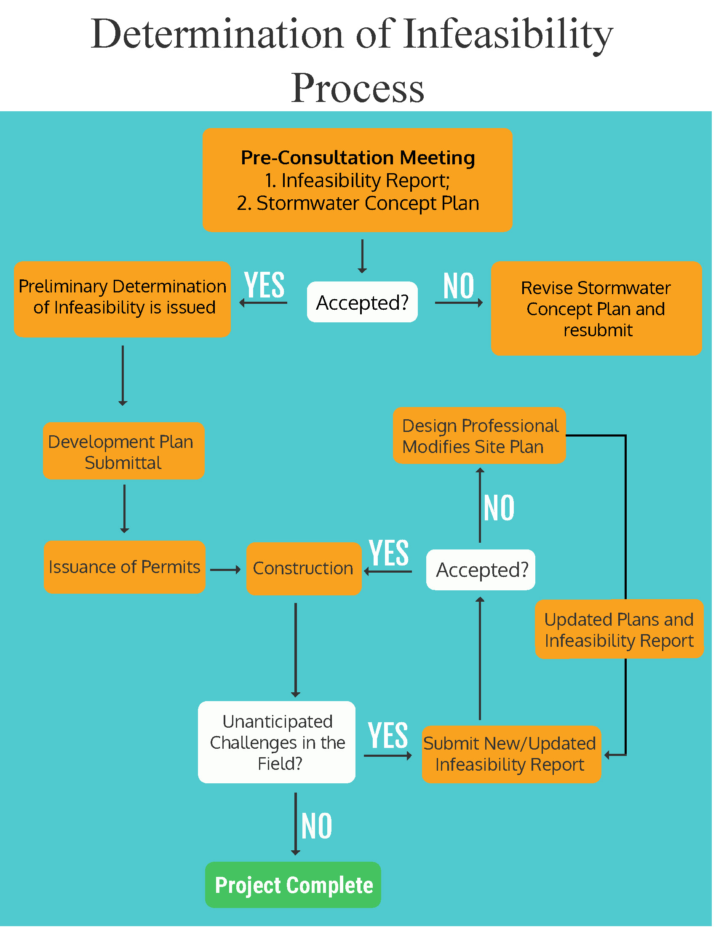

Appendix B:
Template for a Runoff Reduction Infeasibility Form

Date (submitted):

[Insert Local Jurisdiction Name]
Runoff Reduction Infeasibility (RRI) Form for
Determination of Infeasibility
Design Professional Primary Contact (Name/Email/Phone):

Description of Site/Land Development Application Number:
Address:
Size (acres):
Maximum Practicable Runoff Reduction Volume*:
*If any of the stormwater runoff volume generated by the first 1.0” of rainfall cannot be reduced or retained on the site, due to site characteristics or constraints, the remaining volume shall be increased by a multiplier of 1.2 and shall be intercepted and treated in one or more best management practices that provide at least an 80 percent reduction in total suspended solids.

GENERAL SUPPORTING DOCUMENTATION
All General Supporting Documentation must be included with this RRI Form for the submittal for a Determination of Infeasibility to be considered complete. Please check each item below to confirm it has been included in the submittal package.
- Stormwater Concept Plan that has been developed based on site analysis, and natural resources inventory (including impracticability) in accordance with Section 2.4.2.5 of the GSMM
- GSMM Stormwater Quality Site Development Review Tool for the Stormwater Concept Plan
- Please include justification that the site cannot accommodate best management practices that rely on evapotranspiration and reuse such as rainwater harvesting or green roofs

SITE CONDITION APPLICABILITY
(descriptions are in Policy on Practicability Analysis for Runoff Reduction)

Please check each applicable item below and confirm the supporting documentation has been included in the submittal for a Determination of Infeasibility.
Site Condition | Supporting Documentation
- Soil Infiltration Rate | Infiltration test(s), Soil Boring Log(s), and Report of results as interpreted by a Professional Engineer, Professional Geologist, or Soil Scientist licensed in Georgia
- Water Table | Soil Boring Log(s) and Report with results of the seasonal high-water table assessment as interpreted by a Professional Engineer, Professional Geologist, or Soil Scientist licensed in Georgia
- Bedrock | Soil Boring Log(s) and Report with results of the shallow bedrock assessment as interpreted by a Professional Engineer, Professional Geologist, or Soil Scientist licensed in Georgia
- Extreme Topography | Site survey showing 50% of the site is steeper than 3:1 slopes as interpreted by a Professional Engineer or Land Surveyor licensed in Georgia AND Stormwater Concept Plan showing the proposed post-development condition will not change from the site survey
- Karst Topography | Report developed by a Professional Engineer, Professional Geologist, or Soil Scientist licensed in Georgia
- Hotspots/ Contamination | Phase I Environmental Assessment Report
- Historic Resources | Documentation of the NAHRGIS listing  OR  Report of assessment from a Preservation Professional (including Archaeologist, Architectural Historian, Historian, Historic Preservationist, or Historic Preservation Planner)
- Site Constraints | Site Plan identifying all development requirements (e.g. zoning side/front setbacks, build-to-lines, stream buffers, floodplains, septic fields) that are creating irreconcilable conflicts with on-site runoff reduction
- Economic Hardship* | An estimated cost comparison of proposed runoff reduction practices compared to the proposed water quality practices must be included to demonstrate an economic hardship and must show the cost of providing runoff reduction is a minimum of three times greater than the cost of providing water quality practices

* Note: A Determination of Infeasibility cannot be granted solely for economic hardship and must be present with another site condition. Additionally, a Determination of Infeasibility for economic hardship may only be allowed for up to 50% runoff reduction volume.

STORMWATER RUNOFF QUALITY/ REDUCTION SUMMARY
Maximum Practicable Runoff Reduction Volume*:
Remainder of Volume treated by Water Quality Best Management Practice:
*If any of the stormwater runoff volume generated by the first 1.0” of rainfall cannot be reduced or retained on the site, due to site characteristics or constraints, the remaining volume shall be increased by a multiplier of 1.2 and shall be intercepted and treated in one or more best management practices that provide at least an 80 percent reduction in total suspended solids.

Design Professional Printed Name

Design Professional Signature

FOR [INSERT LOCAL JURISDICTION NAME] USE ONLY
- APPROVED
- APPROVED with conditions
- DENIED
Reviewer:
(Print Name) |  |  |  | (Signature) | (Date)

