Model Policy on Stormwater Management Feasibility for Public Linear Transportation Projects
Introduction
Linear transportation facilities contribute significant impervious surface to a watershed. They have historically focused on designs to manage stormwater quantity through drainage, gutter spread, and conveyance that prioritize public safety, roadway function, and protection of property by preventing ponding on roadway surfaces. However, stormwater management along transportation corridors should also include preventing impacts to waterbodies by including designs for runoff reduction, water quality, channel protection and flood attenuation. Designing to these stormwater management standards meet traditional safety and functionality goals while also supporting watershed protection.
Georgia Environmental Protection Division (EPD) requires post-construction stormwater management performance standards be incorporated into the design of new development and redevelopment linear transportation projects, to help mitigate impacts. However, these standards may be infeasible to apply, partially or fully, under certain conditions. A jurisdiction may choose to develop a feasibility program which sets reasonable criteria and documentation requirements for a determination that implementing the post-construction stormwater management standards for a public (constructed by local jurisdiction) linear transportation project is infeasible, called a “Linear Transportation Feasibility Program”.
A Linear Transportation Feasibility Program is not required, but the Metropolitan North Georgia Water Planning District (Metro Water District) has developed this Model Policy on Stormwater Management Feasibility for Public Linear Transportation Projects (Model Policy) as guidance for local jurisdictions that would like to implement a Linear Transportation Feasibility Program. This Model Policy is a starting point for local jurisdictions who want to adopt clear internal criteria for public linear transportation projects, to support decision-making about the feasibility of stormwater management standards under project specific conditions. Local jurisdictions may customize this Model Policy, but the final adopted program policy must meet the requirements of a local jurisdiction’s Municipal Separate Storm Sewer System (MS4) permit (if applicable).
Although EPD has reviewed this document, local jurisdictions must still individually submit their final Linear Transportation Feasibility Program to EPD for review even if it follows the Model Policy. Once it has been reviewed and approved by EPD, local jurisdictions are responsible for implementation.
This document includes:

- Guiding principles
- Definitions
- Criteria for determining infeasibility during
  - Project planning/concept phase (Table 1)
  - Design phase (Table 2 & Table 3)
- Supplemental materials
  - Implementation flowchart (Figure 1 & Figure 2)
  - Infeasibility Form Template with checklist and documentation guidance

- Guiding principles
- Definitions
- Criteria for determining infeasibility during
  - Project planning/concept phase (Table 1)
  - Design phase (Table 2 & Table 3)
- Supplemental materials
  - Implementation flowchart (Figure 1 & Figure 2)
  - Infeasibility Form Template with checklist and documentation guidance

Policy Principles
This Model Policy is based on the following policy principles:
- Linear projects differ from traditional site development due to limited space along narrow right-of-ways and easements, compacted soils and varying soil composition along the length of the project, and greater numbers of adjacent properties.
  - The Model Policy does not apply to site development projects, which is informed by the Policy on Practicability Analysis for Runoff Reduction
- The Model Policy applies to new development and redevelopment of public linear transportation projects that require post-construction stormwater management.
  - The Model Policy does not apply to linear transportation projects being developed and constructed by private entities.
- Aligns with requirements in the EPD’s MS4 permit.
- Addresses typical conditions and regulatory environment in the Metro Water District and may not be applicable for all of Georgia.
- Aligns with the Metro Water District’s Model Ordinance for Post-Construction Stormwater Management for New Development and Redevelopment (Model Ordinance), and guidelines in the Georgia Stormwater Management Manual (GSMM).
  - Per the Model Ordinance, the “stormwater management standards” referred to in this Model Policy are Runoff Reduction (RR_{v}), Water Quality (WQ_{v}), Stream Channel Protection (CP_{v}), Overbank Flood Protection (Q_{p25}), and Extreme Flood Protection (Q_{f})
- Supports a robust investigation of stormwater management opportunities for public linear transportation projects.
  - Begins with the assumption that stormwater management standards can be incorporated into the design of public linear transportation projects.
  - Designers must demonstrate that they have explored all reasonable avenues to meet the stormwater management standards before pursuing a Determination of Infeasibility.
- Supports administrators’ decisions in granting a Determination of Infeasibility, while avoiding excessive exemptions or claims of infeasibility that result in poor stormwater management.
  - Requests for both partial and full Determination of Infeasibility are allowed for each stormwater management standard.
  - If meeting the total volume of a stormwater management standard is determined to be infeasible, designers must attempt to provide the feasible stormwater management to prevent or minimize water quality and quantity impacts.
    - Each stormwater control measure (SCM) should be designed and constructed in accordance with the technical recommendations of the GSMM, including sizing to the quantity of feasible runoff volume it receives and is designed to manage.
  - If, due to the conditions noted in this Model Policy, a linear transportation project can only meet some but not all the stormwater management standards, the designer should prioritize based on specific site conditions.
    - For example, if neighbors adjacent to the project experience repeated flooding, overbank and extreme flood protection should be maximized even if runoff reduction volume qualifies for a partial Determination of Infeasibility.

Definitions
Terms used in the Model Policy and the Model Ordinance will have the same definitions:
- Linear transportation projects mean “construction projects on traveled ways including but not limited to roads, sidewalks, multi-use paths and trails, and airport runways and taxiways.”

- Linear feasibility program means “a feasibility program developed by local jurisdiction and submitted to the Georgia Environmental Protection Division, which sets reasonable criteria for determining when implementation of stormwater management standards for linear transportation projects being constructed by local jurisdiction is infeasible.”

- Post-Construction Stormwater Management means “stormwater best management practices that are used on a permanent basis to control and treat runoff once construction has been completed in accordance with a stormwater management plan.”

- Stormwater Control Measure or SCM, used here interchangeably with Best Management Practice or BMP, means “both structural devices to store or treat stormwater runoff and non-structural programs or practices which are designed to prevent or reduce the pollution of the waters of the State of Georgia.”

- Runoff Reduction (RR_{v}) means “the stormwater management system shall be designed to retain the first 1.0 inch of rainfall on the site using runoff reduction methods, to the maximum extent practicable.”

- Water Quality (WQ_{v}) means “the stormwater management system shall be designed to remove at least 80% of the calculated average annual post-development total suspended solids (TSS) load or equivalent as defined in the GSMM for runoff from a 1.2 inch rainfall event.”

- Stream Channel Protection (CP_{v}) means “Stream channel protection shall be provided by using all of the following three approaches:
  - 24-hour extended detention storage of the 1-year, 24-hour return frequency storm event;
  - Erosion prevention measures, such as energy dissipation and velocity control; and
  - Preservation of any applicable stream buffer.”

- Overbank Flood Protection (Q_{p25}) means “Downstream overbank flood protection shall be provided by controlling the post-development peak discharge rate to the pre-development rate for the 25-year, 24-hour storm event.

- Extreme Flood Protection (Q_{f}) means “Extreme flood protection shall be provided by controlling the 100-year, 24-hour storm event such that flooding is not exacerbated.”

Conditions that may warrant a Determination of Infeasibility

- The following tables list reasonable criteria for a Determination of Infeasibility, generally in order of conditions encountered or known during different project phases.
- Conditions should not be applied on a project-wide basis, except for those conditions listed in Table 1.

Conditions: Project Extent or Purpose
Timeframe: Conceptual Design and/or Early Project Planning

The conditions listed in Table 1 represent criteria encountered during conceptual design and/or early in project planning phases that could warrant a full project Determination of Infeasibility.
Table 1: Conditions Encountered During Conceptual Design and/or Early Project Planning
Condition | Guidance
Involves  less than 1 acre of land disturbing activity | Land disturbing activity is activity which may result in soil erosion from water or wind and the movement of sediments into state water or onto lands within the state  Limitations: Total land disturbance area should account for all project phases
and
¹Creates, adds, or replaces less than 5,000 sq ft of impervious area | Impervious area is composed of any material that significantly impedes or prevents the natural infiltration of water into the soil  Limitations: Total impervious area should account for all project phases
Safety or Maintenance | Project is being done solely for safety or maintenance purposes  Note: See Figure 1 flowchart for examples
Conditions: Administrative or Policy
Timeframe: Design
The conditions listed in Table 2 represent criteria encountered during a project’s design phase. These conditions are mainly administrative or policy driven.
They may warrant a full or partial Determination of Infeasibility for one or more stormwater management standards. These conditions should be considered at a given subbasin, outfall and/or SCM and not project wide.
Table 2: Administrative or Policy Conditions Encountered During Design
Condition | Guidance
Safety Concern | Implementation of an SCM is the sole reason a safety concern is introduced
Crosscutting Authorities | Compliance with local stormwater regulations would cause a violation of a State or Federal law, regulation, or standard or a violation of other local requirements  Limitations: Reference Opinion 2013-3 from the Office of Law for state decision (2013-3 | Office of the Attorney General)
Displacement | Implementation of the SCM would require permanent displacement of residences, businesses, or utilities  Limitations:  - A good faith effort to coordinate with impacted resident, business, or utility owner should be made prior to claiming infeasibility  - Infeasibility for utility displacement should be limited to large scale, difficult to move utilities and not applied for routine 811 and local relocation work
Impacts to Ecological Resources | Implementation of a stormwater management practice would permanently impair or alter ecological resources
Impacts to Community Resources | Implementation of a stormwater management practice would permanently impair or alter community resources
Impacts to Historical Resources | Implementation of a stormwater management practice would permanently impair or alter historical resources
Economic Hardship | The cost of constructing the SCM exceeds fifteen percent (15%) of the cost associated with the portion of the project that drains to that SCM. The cost for construction of the SCM up to 15% should be deemed feasible.  If claiming infeasibility within 1 linear mile upstream of and within the same watershed as a designated trout stream, the cost increases to thirty percent (30%).  Limitations:  - Determination of Infeasibility should not be granted solely for economic hardship and must be present with another condition;  - Costs that may NOT be considered in claim include: right-of-way purchase (unless it is solely for the purpose of constructing the SCM), architectural, engineering and other design work, construction costs for typical drainage structures that convey runoff (for example, curbs, gutters, inlets, catch basins, and pipes)
Conditions: Technical and Location Specific
Timeframe: Encountered During Design
The conditions listed in Table 3 represent criteria encountered during a project’s design phase. These conditions are more technical and specifically location driven.
They may warrant a full or partial Determination of Infeasibility for one or more stormwater management standards. These conditions should be considered at a given subbasin, outfall and/or SCM and not project wide.
Table 3: Technical and Location Specific Conditions Encountered During Design
Condition | Guidance
Karst Topography | If any of the existing conditions is karst or the project overlays a known karst area
Extreme Topography | In the final proposed condition, the topography does not allow for feasible maintenance/access (too steep) or positive drainage due to lack of vertical fall (too flat)
Soil Infiltration Rate | The soil infiltration rate at the location of the SCM is less than the recommended rate for that SCM as defined in the GSMM.  Limitations: Consideration should be given to infiltration rates throughout the soil profile
Small Size | If, for any of the five stormwater management standards, less than 50% can be infiltrated or stored on site due to size constraints (space availability), then a full Determination of Infeasibility can be granted
Sheet Flow | Stormwater discharges from the right-of-way as sheet flow and remains as sheet-flow (overland flow) until reaching a larger waterbody designated as waters of the State  Limitations:  - Cannot be claimed if the discharge will likely cause erosion, slope instability, or downstream flooding; or  - If the discharge flows into a channel, ditch, inlet or other conveyance that results in channelized flow immediately downstream of project site

Supplemental Materials
The Metro Water District has prepared supplemental materials to support the implementation of a Linear Transportation Feasibility Program following this Model Policy. They are meant for internal use to guide local jurisdiction staff.
Appendix I. Flowcharts for deciding applicability of Determination of Infeasibility
Appendix II. Infeasibility Form Template, with supporting documentation checklist and requirements

Appendix I –

Implementation Flowcharts

Figure 1: Infeasibility Conditions in Early Project Planning Phase
Figure 2: Infeasibility Conditions in Design Phase

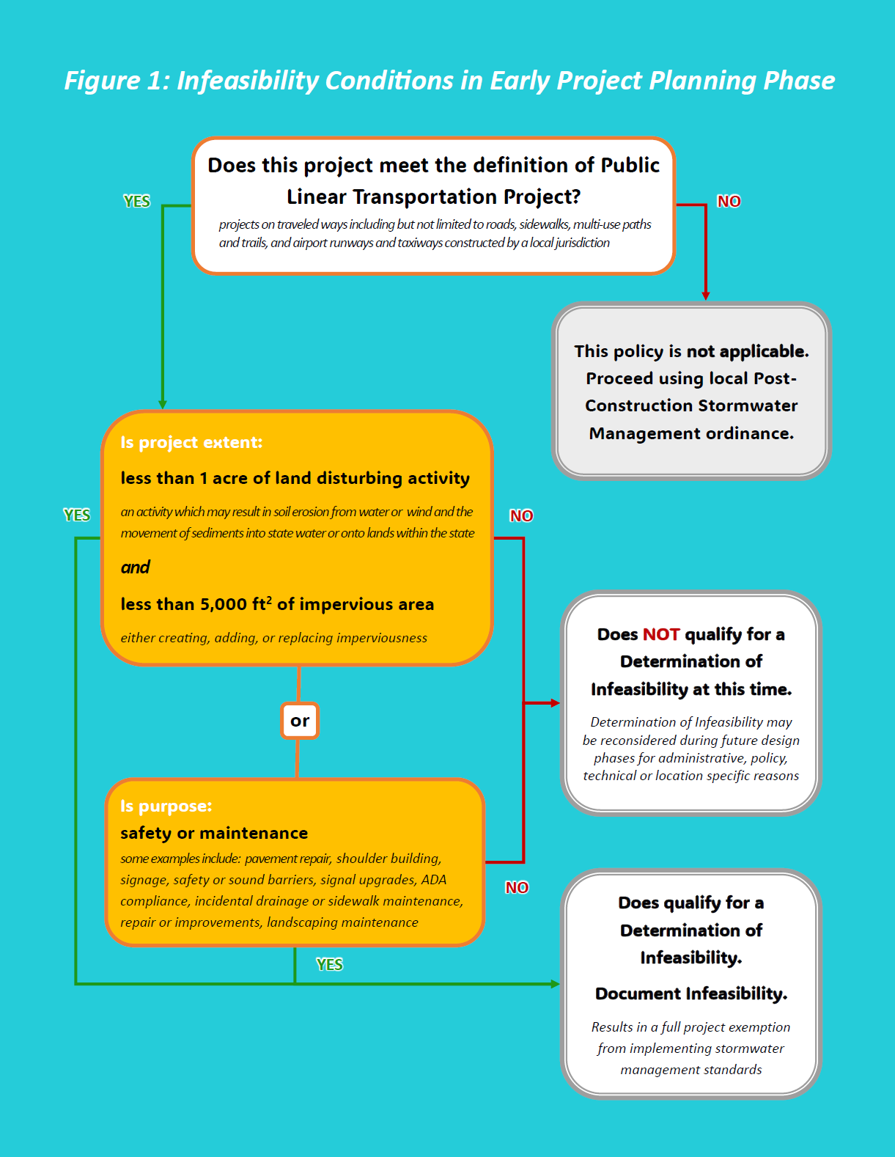

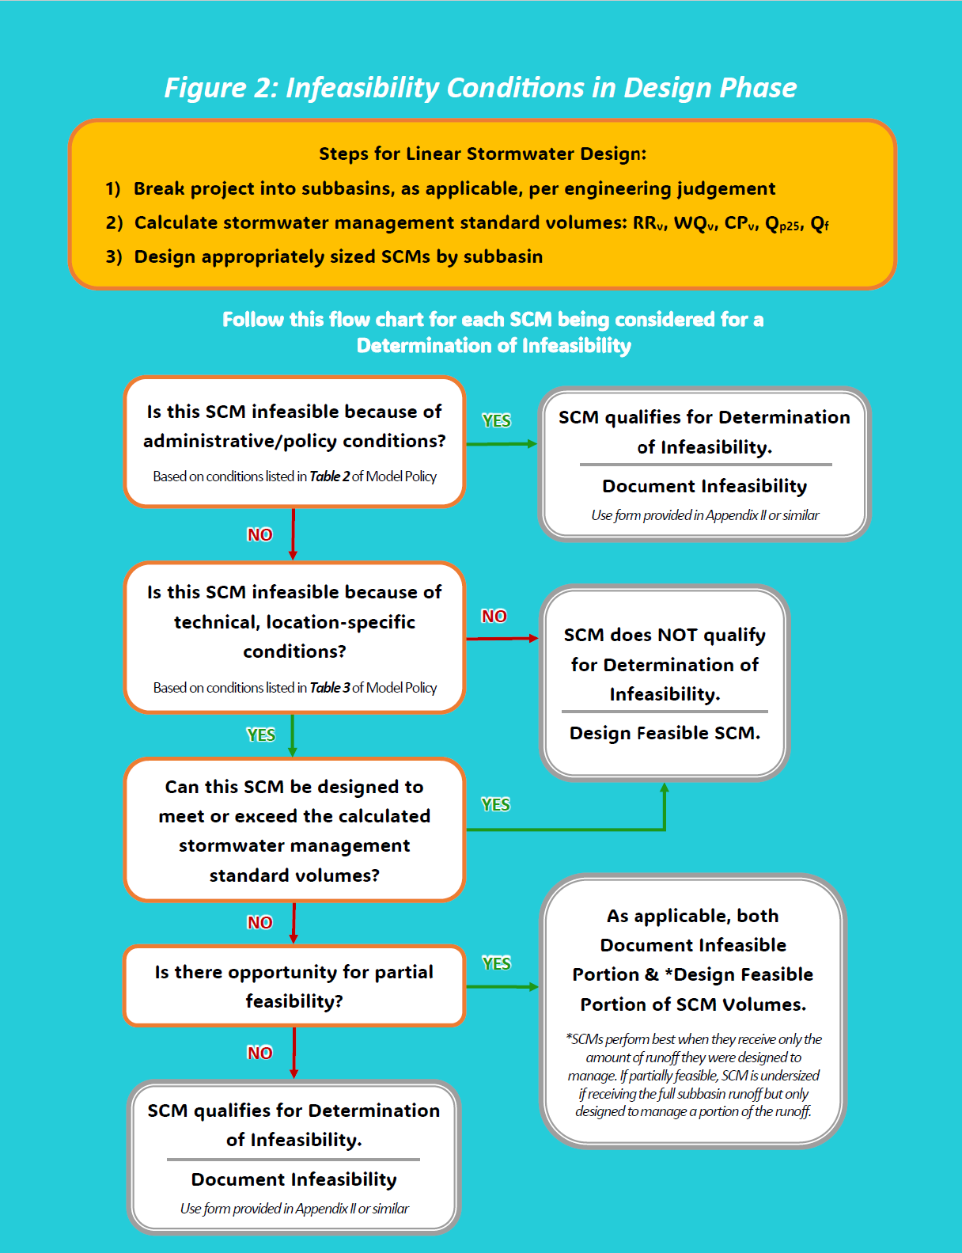

Appendix II –

Infeasibility Form Template

Date (submitted): Version (for this submittal): _________

[Insert Local Jurisdiction Name]
Linear Transportation Project Stormwater Management Form for
Determination of Infeasibility

Project Name (ID):
Project Location:
Project Description/Purpose:
Linear Transportation Project Full Stormwater Summary

Total Length (mi): _________________________
Total Size (acres): _________________________
Disturbed Area (acres): ___________________
Impervious Area Added (ft²): ______________

Details Relevant to Claimed Condition(s)

Condition Name: _________________________
Subbasin / SCM ID: _______________________
Max Feasible SWM Volume (ft³): ____________
Total Infeasible SWM Volume (ft³):___________

Check Stormwater Management (SWM) Standard(s) being requested for a Determination of Infeasibility. For each checked standard, circle full or partial and write infeasible volume.

Stormwater Management Standard | Level of Infeasibility | Infeasible Vol. (ft³)
- All SWM Standards | Full
- Runoff Reduction (RR_{v}) | Partial / Full
- Water Quality (WQ_{v}) | Partial / Full
- Stream Channel Protection (CP_{v}) | Partial / Full
- Overbank Flood Protection (Q_{p25}) | Partial / Full
- Extreme Flood Protection (Q_{f}) | Partial / Full
Undersized SCMs will not be considered for partial infeasibility. A SCM should be designed to treat the feasible, partial volume.
Professional Certification
This request for a Determination of Infeasibility Form and attached documentation have been reviewed, signed, and sealed by a design professional licensed in the state of Georgia. Any SCM claiming partial feasibility is sized properly to collect and manage the partially feasible volume in accordance with the GSMM.

Design
Professional
Seal
Design Professional Name (printed): ______________________________________
Design Professional Signature: ___________________________________________
Date: ___________________________
Email: __________________________ Phone: _________________________
Documentation Requirements
The following documentation must be included with this Form for a Determination of Infeasibility to be considered. Please check each item below to confirm it is in the submittal.
Documentation for all submittals:
- Written analysis with justification for why one or more of the stormwater management standards is infeasible for all or part of the Linear Transportation Project, specifically noting the applicable condition(s).

Documentation for submittals claiming condition(s) in Table 2 or Table 3 of Model Policy:
- Stormwater Concept Plan that has been developed in accordance with GSMM Volume 2 Section 2.4.2.5 and Local Post-Construction Stormwater Management Ordinance
- Downstream Analysis (for guidance, reference GSMM Vol 2 Section 3.1.9, or GDOT Stormwater Design Guide Section 2.2.3)

Documentation based on applicable condition(s):
Condition | Supporting Documentation
- < 1 Acre of Land Disturbing Activity | Site Plan or Map showing total land disturbance areas (including acreage labels) during all project phases
- <5,000 sq ft of Impervious Area | Site Plan or Map showing existing and total proposed impervious areas (including quantities of created, added, or replaced areas labeled in sq ft) during all project phases
- Maintenance | Narrative describing maintenance purpose, along with documentation such as photos, public comments, or Operations & Maintenance guidance
- Safety | Narrative describing safety purpose/ concern, along with documentation such as photos, public comments, reference to law, regulation or standard (AASHTO, FHWA, ADA or other)
- Crosscutting Authorities | Reference to the law, regulation or standard that would be violated
- Displacement | Site Plan or Map showing displaced residence, business or utility AND documented communication(s) showing good faith effort to coordinate with impacted property or utility owner
- Impacts to Ecological Resources | Site Plan or Map showing location of proposed SCM and limits of protected resource AND  ecology report showing negative impact to an ecological resource, with references to official national or state resources inventory databases, as applicable
- Impacts to Community Resources | Site Plan or Map showing location of proposed SCM and limits of protected resource AND  documentation of the resource from an official national or state database OR written concurrence from the local jurisdiction of the negative impact the proposed SCM will have to a community resource.
- Impacts to Historical Resources | Site Plan or Map showing location of proposed SCM and limits of protected resource AND  documentation of the NAHRGIS listing OR  report of assessment from a Preservation Professional (e.g. Archaeologist, Architectural Historian, Historian, Historic Preservationist, or Historic Preservation Planner)
- Economic Hardship | Cost estimate including line items for linear transportation project elements and proposed feasible and infeasible SCMs being considered; a cost estimate should be completed for each individual SCM for which a Determination of Infeasibility is claimed
- Karst Topography | Report developed by a Professional Engineer, Professional Geologist, or Soil Scientist licensed in Georgia OR  Site Plan or Map showing SCM location overlaid on the local jurisdiction’s current map of karst topography used for plan review
- Extreme Topography | Site Plan showing proposed SCM location, topographic contours, existing and proposed grading, and other information, and a narrative to justify why final topography is too steep or too flat to feasibly infiltrate or store stormwater management volumes
- Soil Infiltration Rate | Infiltration test(s), Soil Boring Log(s), and report of results as interpreted by a Professional Engineer, Professional Geologist, or Soil Scientist licensed in Georgia
- Small Size | Site Plan or Map showing site boundary and proposed SCM footprint AND Hydrology Report reflecting the total and infeasible stormwater management volumes
- Sheet Flow | Site Plan or Map showing drainage basin delineation, topographic contours, proposed grading, ROW boundary, and larger waterbody(s) designated as waters of the State  AND  Calculations proving sheet flow will not cause instability, erosion, or flooding downstream of the project (Downstream Analysis)

FOR [INSERT LOCAL JURISDICTION NAME] INTERNAL USE ONLY
- APPROVED
- APPROVED with conditions
- DENIED
Reviewer:
(Print Name) |  |  |  | (Signature) | (Date)

APPROVED means a Determination of Infeasibility is issued.
APPROVED with conditions means a Determination of Infeasibility is issued with conditions to incorporate plan reviewer comments into the Stormwater Concept Plan.
DENIED means no Determination of Infeasibility is issued. The Stormwater Concept Plan must be revised to meet applicable stormwater management standards.

MS4 permittees should check the most current MS4 permit for the local jurisdiction prior to performing a request for Determination of Infeasibility to confirm the first condition in Table 1, and the rest of this policy, is still applicable and aligns with the MS4 permit.

