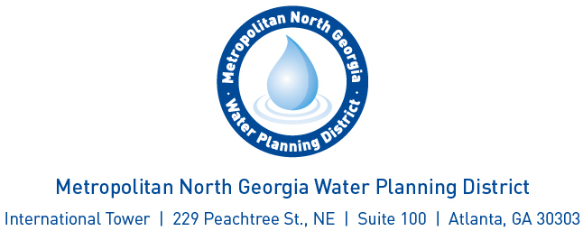

Agenda
Cost Benefit Analysis Committee

August 13, 2019 – 2 to 3 p.m.
Conference Call: 712-770-4700
Access Code: 382125

1. Welcome

2. Discussion and Consideration of the Cost-Benefit Framework
3. Adjourn

