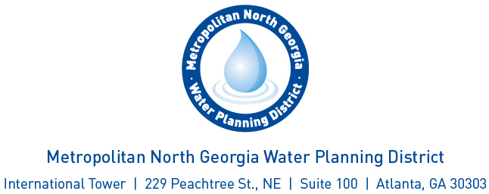

**Agenda**

**Cost Benefit Analysis Committee**

August 13, 2019 – 2 to 3 p.m.

Conference Call: 712-770-4700

Access Code: 382125

1. Welcome

2. Discussion and Consideration of the Cost-Benefit Framework

3. Adjourn